Ex.No: 1 a DATA DEFINITION LANGUAGE

AIM:
To study and execute the DDL Commands in RDBMS

PROCEDURE:

Definition and Syntax SQL:
SQL Stands Structured Query Language. SQL composed of commands that enable users to create database and table structures perform various type of data manipulation and data administration and query the database to extract useful information.

Data Definition Language (DDL)
The Language used to define the database schema is called data definition language. DDL is to create, update and drop the database. The commands used for DDL are
CREATE ALTER RENAME TRUNCATE DROP

SQL: create command
Create is a DDL SQL command used to create a table or a database in relational database management system.

Creating a Database
To create a database in RDBMS, create command is used. Following is the syntax,

CREATE DATABASE <DB_NAME>;
Example for creating Database CREATE DATABASE dbms;
The above command will create a database named dbms, which will be an empty schema without any table.
To create tables in this newly created database, we can again use the create command.

Creating a Table
Create command can also be used to create tables. Now when we create a table, we have to specify the details of the columns of the tables too. We can specify the names and data types of various columns in the create command itself.

Following is the syntax,
CREATE TABLE <TABLE_NAME>

( column_name1 datatype1, column_name2 datatype2, column_name3 datatype3,.............
column_namen datatypen );
create table command will tell the database system to create a new table with the given table name and column information.

SQL: ALTER command
alter command is used for altering the table structure, such as, to add a column to existing table to rename any existing column to change datatype of any column or to modify its size. to drop a column from the table.

ALTER Command: Add a new Column
Using ALTER command we can add a column to any existing table. Following is the syntax, ALTER TABLE table_name ADD( column_name datatype);

ALTER Command: Add multiple new Columns
Using ALTER command we can even add multiple new columns to any existing table. Following is the syntax,
ALTER TABLE table_name ADD( column_name1 datatype1, column-name2 datatype2,…, column-namen datatypen);

ALTER Command: Modify an existing Column
ALTER command can also be used to modify data type of any existing column. Following is the
syntax,
ALTER TABLE table_name modify( column_name datatype);

ALTER Command: Rename a Column
Using ALTER command you can rename an existing column. Following is the syntax, ALTER TABLE table_name RENAME old_column_name TO new_column_name;

ALTER Command: Drop a Column
ALTER command can also be used to drop or remove columns. Following is the syntax, ALTER TABLE table_name DROP( column_name);

RENAME query
RENAME command is used to set a new name for any existing table. Following is the syntax, RENAME TABLE old_table_name to new_table_name

TRUNCATE command
TRUNCATE command removes all the records from a table. But this command will not destroy the table's structure. When we use TRUNCATE command on a table its (auto- increment) primary key is also initialized. Following is its syntax,
TRUNCATE TABLE table_name

DROP command
DROP command completely removes a table from the database. This command will also destroy the table structure and the data stored in it. Following is its syntax,
DROP TABLE table_name

TABLE CREATION:
SQL> create table employee(empid number(5),empname varchar2(10),dept varchar2(20) ,dob date,salary number(6));
Table created.

DESCRIBING TABLE:
SQL> desc employee Name Null? Type

EMPID NUMBER(5) EMPNAME VARCHAR2(10) DEPT VARCHAR2(20)
DOB DATE
SALARY NUMBER(6) ALTERING A TABLE ADDING A NEW CLOUMN:
SQL> alter table employee add date of joining date; Table altered.

DESCRIBING A TABLE:
SQL> desc employee; Name Null? Type

EMPID NUMBER(5) EMPNAME VARCHAR2(10) DEPT VARCHAR2(20)
DOB DATE
SALARY NUMBER(6) DATEOFJOINING DATE

MODIFY:
SQL> alter table employee modify empname varchar2(15); Table altered.
SQL> desc employee; Name Null? Type
EMPID NUMBER(5) EMPNAME VARCHAR2(15) DEPT VARCHAR2(20)
DOB DATE
SALARY NUMBER(6) DATEOFJOINING DATE DROPING A CLOUMN:
SQL> alter table employee drop column date of joining; Table altered.
DESCRIBING A TABLE: SQL> desc employee; Name Null? Type

EMPID NUMBER(5) EMPNAME VARCHAR2(15) DEPT VARCHAR2(20)
DOB DATE
SALARY NUMBER(6)

TRUNCATE:
SQL> truncate table employee; Table truncated.

RENAME:
SQL> rename employee to emp; Table renamed

RESULT:

Thus the table was created successfully and applied all the DDL commands.

VIVA QUESTIONS:

What is Data Definition Language (DDL)?

What are the primary commands in DDL?

What is the purpose of the ALTER command in DDL?

Differentiate between TRUNCATE and DROP commands.

What is a constraint in DDL?

ASSIGNMENTS
Q.No | Questions | CO Mapping | BT Level | Complexity
1 | Create a table named Employees with the following columns:EmployeeID (integer, primary key)  FirstName (varchar, maximum length 50)  LastName (varchar, maximum length 50)  DateOfBirth (date)  DepartmentID (integer, foreign key referencing the Department table's DepartmentID) | CO2 | Create | High
2 | Remove the DateofBirth column from the Employees table | CO2 | Create | High

Ex no: 1 b SQL CONSTRAINTS

AIM:
To add and execute the constraints in create command

PROCEDURE:
To practice basic SQL constraints like NOT NULL, primary key and check constraints.
Constraints:
Constraints are used to limit the type of data, that can go into a table this ensures the accuracy and reliability of the data in the table.
If there is any violation between the constraints and the data action, the action is aborted.

Primary Key constraints:
A combination of NOT NULL and unique uniquely identifies each row in the data.
Syntax:
Create table tablename(column1 datatype1 primary key, coulmn2 datatype2,…..column datatypen);
Eg:
Create table branches(branched number(10) primary key, branchname varchar2(20));

Unique Constraints
It ensures that all the values in a column are different

Syntax:
Create table tablename(column1 datatype1, column2 datatype2, columnn datatypen unique);
Eg:
Create table person(id int NOT NULL unique, lastname varchar2(25),firstname varchar2(25) not null, age int);
Check Constraint
It works for numerical value conditions ensures that the values in a column satisfies a specific condition

Syntax:
Create table tablename(column1 datatype1, column2 datatype, colunmn3 datatype3. check condition);
Eg:
Create table person(id int NOT NULL,lastname varchar2(25) NOT NULL,Firstname varchar2(25),age int check(age>=18));
NOT NULL constraints:
It ensures that a column cannot have a null value

Syntax:
Create table tablename(column1 not null,column2 not null,column3 not null); Eg:
Create table person(id int NOT NULL,lastname varchar2(25) NOT NULL,firstname varchar2(25) NOT NULL, age int );

NOT NULL CONSTRAINT:
SQL> create table stud(rollno number(5) not null,studname varchar2(10),dob date, joiningyear number(5),dept varchar2(5));
Table created.
SQL> insert into stud values(101,'akash','21-jul-1999',2017,'cse'); 1 row created.
SQL> insert into stud values('','ram','22-aug-1999',2017,'eee'); insert into stud values('','ram','22-aug-1999',2017,'eee') ERROR at line 1:
ORA-01400: cannot insert NULL into ("CSE132"."STUD"."ROLLNO")

DEFAULT CONSTRAINT:
SQL> create table stud3(rollno number(5),studname varchar2(10),joining year number(5)default10,dept varchar2(5));
Table created.

SQL> insert into stud3(rollno,studname,dept)values(108,'divya','ece'); 1 row created.
SQL> insert into stud3(rollno,studname,dept)values(117,'ramya','eee'); 1 row created.
SQL> select * from stud3;
ROLLNO STUDNAME JOININGYEAR DEPT
108 divya 10 ece
117 ramya 10 eee

CHECK CONSTRAINT:
SQL> create table stud4(rollno number(5) not null,studname varchar2(10),joiningyear number(5)default 10,dept varchar2(5),age number(5)check (age>17));
Table created.
SQL> insert into stud4(rollno,studname,dept,age)values(170,'sivani','eee',17); SQL> insert into stud4(rollno,studname,dept,age)values(140,'shruthi','eee',19); insert into stud4(rollno,studname,dept,age)values(140,'shruthi','eee',16) ERROR at line 1:
ORA-02290: check constraint (CSE132.SYS_C0012437) violated

UNIQUE CONSTRAINT:
SQL> create table stock1(itemno number(5)unique,itemname varchar2(10)not null,qu quantity number(5));
Table created.
SQL> insert into stock1 values(111,'pendrive',15); 1 row created.
SQL> select * from stock1; ITEMNO ITEMNAME QUANTITY
111 pendrive 15
SQL> insert into stock1 values(111,'cd',20); insert into stock1 values(111,'cd',20)
*
ERROR at line 1:
ORA-00001: unique constraint (CSE132.SYS_C0012501) violated

PRIMARY KEY:
SQL> create table stock3(itemno number(5)primary key ,itemname varchar2(10)); Table created.
SQL> insert into stock3 values('','pendrive'); insert into stock3 values('','pendrive') ERROR at line 1:
ORA-01400: cannot insert NULL into ("CSE132"."STOCK3"."ITEMNO")
SQL> insert into stock3 values('3','cd'); 1 row created.
SQL> insert into stock3 values('3','dvd'); insert into stock3 values('3','dvd') ERROR at line 1:
ORA-00001: unique constraint (CSE132.SYS_C0012551) violated

RESULT:
Thus the SQL constraints like primary key, unique, check and not null constraints are executed successfully.

VIVA QUESTIONS:

What is a constraint in SQL?

Name and explain the types of constraints supported in SQL.

What is the purpose of the NOT NULL constraint?

How is a PRIMARY KEY constraint different from a UNIQUE constraint?

What is the significance of an INDEX constraint in SQL?

How is the DEFAULT constraint used in SQL?

ASSIGNMENTS

Q.No | Questions | CO Mapping | BT Level | Complexity
1 | Create a table named Students with the following columns:  StudentID (integer, primary key)  FirstName (varchar, maximum length 50, not null)  LastName (varchar, maximum length 50, not null)  DateOfBirth (date, not null)  Email (varchar, maximum length 100, unique) Ensure that the FirstName, LastName, and DateOfBirth columns cannot contain NULL values, and the Email column must have unique values | CO2 | Create | High
2 | Create a table named Orders with the following columns: OrderID (integer, primary key)  CustomerID (integer, foreign key referencing the Customers table's CustomerID)  OrderDate (date, not null)  TotalAmount (numeric, not null) Ensure that the OrderDate column cannot contain NULL values and the TotalAmount column must have values greater than zero | CO2 | Create | High

Ex:No: 1 c DATA MANIPULATION COMMANDS

AIM:
To execute the Data Manipulation Commands

PROCEDURE:

INSERT:
ONETIME INSERTION:
SQL> insert into emp values(1181,'harini','production','16-jun-1999',30000); 1 row created.

SELECT:
SQL> select * from emp;
EMPID EMPNAME DEPT DOB SALARY

1181 harini production 16-JUN-99 30000

PARTICULAR COLUMN INSERTION:
SQL> insert into emp(empid) values(1021); 1 row created.

SELECT:
SQL> select * from emp;
EMPID EMPNAME DEPT DOB SALARY
1181 harini production 16-JUN-99 30000
1021

RUNTIME INSERTION:
SQL> insert into emp values(&empid,'&empname','&dept','&dob',&salary); Enter value for empid: 1112
Enter value for empname: krithikaa Enter value for dept: marketing Enter value for dob: 20-dec-1999 Enter value for salary: 50000
old 1: insert into emp values(&empid,'&empname','&dept','&dob',&salary) new 1: insert into emp values(1112,'krithikaa','marketing','20-dec-1999',50000) 1 row created.

SELECT:
SQL>SQL> select * from emp;
EMPID EMPNAME DEPT DOB SALARY
1181 harini production 16-JUN-99 30000 1021
1112 krithikaa marketing 20-DEC-99 50000

UPDATE:
SQL> update emp set salary=50000; 3 rows updated.

SELECT:
SQL> select * from emp;
EMPID EMPNAME DEPT DOB SALARY
1181 harini production 16-JUN-99 50000
1021 50000

1112 krithikaa marketing 20-DEC-99 50000

DELETE:
SQL> delete from emp where empid=1021; 1 row deleted.

SELECT:
SQL> select * from emp;
EMPID EMPNAME DEPT DOB SALARY

1181 harini production 16-JUN-99 50000
1112 krithikaa marketing 20-DEC-99 50000
SQL> insert into emp values(1232,'aruna','design','03-sep-1999',65000); 1 row created.
SQL> select * from emp;
EMPID EMPNAME DEPT DOB SALARY

1181 harini production 16-JUN-99 50000
1232 aruna design 03-SEP-99 65000
1112 krithikaa marketing 20-DEC-99 50000

RESULT:

Thus the DML commands are executed successfully

VIVA QUESTIONS:

What is Data Manipulation Language (DML) in SQL?

What are the primary commands in DML?

Explain the purpose of the SELECT statement in SQL.

How do you use the UPDATE statement in SQL?

Explain the purpose of the UPSERT operation.

How do you use the MERGE statement in SQL?

ASSIGNMENTS

Q.No | Questions | CO Mapping | BT Level | Complexity
1 | Insert a new record into the Employees table with the following details:  EmployeeID: 101  FirstName: John  LastName: Doe  DepartmentID: 001  Salary: 50000 | CO1 | Create | High
2 | Update the salary of the employee with Delete the record of the employee Employee ID 101 to 55000 Employees table | CO1 | Create | High

Ex: No: 2 REFERENTIAL INTEGRITY
AIM:
To create a set of tables, add foreign key constraints and incorporate referential integrity.

PROCEDURE:
Referential Integrity
A referential integrity constraint is also known as foreign key constraint. A foreign key is a key whose values are derived from the Primary key of another table.
The table from which the values are derived is known as Master or Referenced Table and the Table in which values are inserted accordingly is known as Child or Referencing Table, In other words, we can say that the table containing the foreign key is called the child table, and the table containing the Primary key/candidate key is called the referenced or parent table.

Program:
Parent Table:
SQL> create table stock3(itemno number(5)primary key ,itemname varchar2(10)); Table created.
Child Table
SQL> create table stock4(itemno number(5)references stock3(itemno),price number(5)); Table created.
SQL> insert into stock4 values(3,100); 1 row created.
SQL> insert into stock4 values(3,100); 1 row created.
SQL> select * from stock4; ITEMNO PRICE
3 100
SQL> insert into stock4 values(2,100); insert into stock4 values(2,100)
*
ERROR at line 1:
ORA-02291: integrity constraint violated - parent key not found

RESULT:

Thus the Create a set of tables, add foreign key constraints and incorporate referential integrity are executed successfully.

VIVA QUESTIONS:

- What is referential integrity in databases?
- Explain the importance of referential integrity in a database.
- How is referential integrity enforced in a relational database?
- What is a foreign key constraint?
- Can a table have multiple foreign key constraints?
- How do you drop a foreign key constraint from a table?

ASSIGNMENTS

Q.No | Questions | CO Mapping | BT Level | Complexity
1 | Create two tables named Employees and Departments with the following columns:  Employees:  EmployeeID (integer, primary key)  FirstName (varchar, maximum length 50)  LastName (varchar, maximum length 50)  DepartmentID (integer, foreign key referencing the Departments table's DepartmentID) | CO1 | Create | High
2 | Insert a new department named “IT” into Departments table and assign it a DepartmentID of 1 | CO1 | Create | High
3 | Insert a new employee named “john smith” into Employees table and assign him to the IT department | CO1 | Create | High

Ex:No: 3 WHERE CLAUSE AND AGGREGATE FUNCTIONS

AIM:
To Query the database tables using different ‘where’ clause conditions and also implement
aggregate functions.

PROCEDURE:
A WHERE clause in SQL is used with the SELECT query, which is one of the data manipulation language commands. WHERE clauses can be used to limit the number of rows to be displayed in the result set, it generally helps in filtering the records. It returns only those queries which fulfill the specific conditions of the WHERE clause. WHERE clause is used in SELECT, UPDATE, DELETE statement, etc. WHERE Syntax
SELECT column1, column2, ... FROM table_name

WHERE condition;
Consider the employee table with the following data:
E_ID | Name | Salary | City | Designation | Date_of_  Joining | Age
1 | Sakshi Kumari | 50000 | Mumbai | Project Manager | 2021-06-20 | 24
2 | Tejaswini Naik | 75000 | Delhi | System Engineer | 2019-12-24 | 23
3 | Anuja Sharma | 40000 | Jaipur | Manager | 2021-08-15 | 26
4 | Anushka Tripathi | 90000 | Mumbai | Software Tester | 2021-06-13 | 24
5 | Rucha Jagtap | 45000 | Bangalore | Project Manager | 2020-08-09 | 23
6 | Rutuja Deshmukh | 60000 | Bangalore | Manager | 2019-07-17 | 26
7 | Swara Baviskar | 55000 | Jaipur | System Engineer | 2021-10-10 | 24
8 | Sana Sheik | 45000 | Pune | Software Engineer | 2020-09-10 | 26
9 | Swati Kumari | 50000 | Pune | Software Tester | 2021-01-01 | 25
10 | Mayuri Patel | 60000 | Mumbai | Project Manager | 2020-10-02 | 24
11 | Simran Khanna | 45500 | Kolhapur | HR | 2019-01-02 | 26
12 | Shivani Wagh | 50500 | Delhi | Software Developer | 2016-09-10 | 25
13 | Kiran Maheshwari | 50000 | Nashik | HR | 2013-12-12 | 23
14 | Tejal Jain | 40000 | Delhi | Project Manager | 2017-11-10 | 25
15 | Mohini Shah | 38000 | Pune | Software Developer | 2019-03-05 | 20

Example 1:
Write a query to retrieve all those records of an employee where employee salary is greater than 50000. Query:
sql> SELECT * FROM employees WHERE Salary > 50000;

Output
2 | Tejaswini Naik | 75000 | Delhi | System Engineer | 2019-12-24 | 23
4 | Anushka Tripathi | 90000 | Mumbai | Software Tester | 2021-06-13 | 24
6 | Rutuja Deshmukh | 60000 | Bangalore | Manager | 2019-07-17 | 26
7 | Swara Baviskar | 55000 | Jaipur | System Engineer | 2021-10-10 | 24
10 | Mayuri Patel | 60000 | Mumbai | Project Manager | 2020-10-02 | 24
12 | Shivani Wagh | 50500 | Delhi | Software Developer | 2016-09-10 | 25
AGGREGATE FUNCTIONS:An aggregate function in SQL performs a calculation on multiple values and returns a single value. SQL provides many aggregate functions that include avg, count, sum, min, max, etc. An aggregate function ignores NULL values when it performs the calculation, except for the count function

- Create Employee table containing all Records.
SQL> create table emp(eid number,ename varchar2(10),age number,salary number); Table created.

SQL> desc emp;
Name Null? Type
EID NUMBER
ENAME VARCHAR2(10) AGE NUMBER
SALARY NUMBER
- Count number of employee names from employee table. SQL> select count(ename) from emp;
COUNT(ENAME)
7
- Find the Maximum age from employee table. SQL> select max(age) from emp;
MAX(AGE)

44
- Find the Minimum age from employee table. SQL> select min(age) from emp;
MIN(AGE)
22
- Display the Sum of age employee table. SQL> select sum(age) from emp; SUM(AGE)
220
- Display the Average of age from Employee table. SQL> select avg(age) from emp;
AVG(AGE)
31.4285714
- Create a View for age in employee table
SQL> create or replace view A as select age from emp where age select * from A; AGE
22 29 27 29
(ix)Find grouped salaries of employees.(group by clause) SQL> select salary from emp group by salary;
SALARY
9000 10000 8000 6000 7000
(x).Find salaries of employee in Ascending Order.(order by clause) SQL> select ename,salary from emp order by salary;
ENAME SALARY
rohan 6000

alex 7000
shane 8000
abhi 8000
tiger 8000
anu 9000
scott 10000

7 rows selected.
(xi) Find salaries of employee in Descending Order. SQL> select ename,salary from emp order by salary desc; ENAME SALARY

scott 10000
anu 9000
shane 8000
abhi 8000
tiger 8000
alex 7000
rohan 6000
7 rows selected. (xii)Having Clause.
SQL> select ename,salary from emp where age ENAME SALARY

alex 7000
anu 9000

RESULT:

Thus the Query database tables using different ‘where’ clause conditions implemented.

VIVA QUESTIONS

What is the purpose of the WHERE clause in SQL?

Can you provide an example of using the WHERE clause in a SELECT statement?

Explain the use of the LIKE operator in the WHERE clause.

What is the purpose of aggregate functions in SQL?

Can you provide an example of using the COUNT function?

What is the purpose of the HAVING clause in SQL?

ASSIGNMENTS

Q.No | Questions | CO Mapping | BT Level | Complexity
1 | Retrieve the total number of orders made by customers with a CustomerID of 1001. | CO3 | Create | High
2 | Calculate the average salary of employees in the Sales department. | CO3 | Create | High
3 | Find the maximum and minimum order amounts placed by customers with a CustomerID between 1001 and 1010. | CO2 | Create | High

Ex. No: 4 SUBQUERIES AND JOIN OPERATIONS

AIM:
To Query the database tables and explore sub queries and simple join operations.

PROCEDURE:
SQL - SELECT Query
The SQL SELECT statement is used to fetch the data from a database table which returns this data in the form of a result table. These result tables are called result-sets.

Syntax
The basic syntax of the SELECT statement is as follows − SELECT column1, column2, columnN FROM table_name; SELECT * FROM table_name;

Sub Query:
While creating a database if we want to extract some information regarding the data in the database then we use a Query. In other words, if we want to retrieve some data from a table or some tables that we created earlier then we write/use a Query.
Sub Queries are very useful for selecting rows from a table having a condition that depends on the data of the table itself. A Sub Query can also be called a Nested/Inner Query. These Sub Queries can be used with:
- WHERE Clause
- SELECT Clause
- FROM Clause
SELECT <column, ...> FROM <table> WHERE expression operator ( SELECT <column, ...> FROM
<table> WHERE <condition> );

Nested Subquery:
A subquery can be nested inside other subqueries. SQL has an ability to nest queries within one another. A subquery is a SELECT statement that is nested within another SELECT statement and which return intermediate results. SQL executes innermost subquery first, then next level
Join:
Join is the most powerful operation for merging information from multiple tables based on a common field. There are various types of joins but an INNER JOIN is the common of them.

Syntax
SELECT col1, col2, col3... FROM table_name1, table_name2 WHERE table_name1.col2 = table_name2.col1;

Eg:
CREATE TABLE Customer ( Cust_id Number(10) NOT NULL, Cust_name varchar2(20), Country varchar2(20), Receipt_no Number(10), Order_id Number(10) NOT NULL, );
CREATE TABLE Orders ( Order_id Number(10), Item_ordered varchar2(20), Order_date date );
Using and ON clause
SELECT Cust_id, Cust_name, Country, item_Ordered, Order_date FROM Customer C JOIN Orders O USING (Order_id);
SELECT Cust_id, Cust_name, Country, item_Ordered, Order_date FROM Customer C JOIN Orders O ON (C.Order_id = O.Order_id);

Equi Join
An Equi join is used to get the data from multiple tables where the names are common and the columns are specified. It includes the equal ("=") operator.

Example
SELECT Cust_id, Cust_name, item_Ordered, Order_date FROM Customer C, Orders O WHERE C.Order_id = O.Order_id;

Program:
SQL OPERATORSSQL> select * from stock1
4 gk pen
7 kkk pen
12 gk pen
12 kk pen
SQL> select *from stock1 where sname='gk'; SNO SNAME ITEM

4 gk pen
12 gk pen
SQL> select *from stock1 where sname !='gk'; SNO SNAME ITEM

7 kkk pen
12 kk pen
SQL> select *from stock1 where sno> 7; SNO SNAME ITEM

12 gk pen
12 kk pen
SQL> select *from stock1 where sno>= 7 and sname='gk'; SNO SNAME ITEM

12 gk pen
SQL> select *from stock1 where sno>= 7 or sname='gk'; SNO SNAME ITEM

4 gk pen
7 kkk pen
12 gk pen
12 kk pen
SQL> select *from stock1 where (sno>= 7 and sname='gk') or (item='pen'); SNO SNAME ITEM

4 gk pen
7 kkk pen
12 gk pen
12 kk pen

SQL> select *from stock1 where (sno>= 7 and sname='gk') order by item;

SNO SNAME ITEM

12 gk pen
SQL> select all sno from stock1 where sname='kkk'; SNO

7
SQL> select distinct sno from stock1 where sname='gk'; SNO

4
12

SQL> select * from stock1 where sname in('gk','kkk'); SNO SNAME ITEM

4 gk pen
7 kkk pen
12 gk pen
SQL> select * from stock1 where sname not in('gk','kkk'); SNO SNAME ITEM

12 kk pen
SQL> select * from stock1 where sname <> 'gk'; SNO SNAME ITEM

7 kkk pen
12 kk pen
SQL> select * from stock1 where sname <> 'null'; SNO SNAME ITEM

4 gk pen
7 kkk pen
12 gk pen
12 kk pen
SQL> select * from stock1 where sname is null;
no rows selected
SQL> select * from stock1 where sname is not null;
SNO SNAME ITEM

4 gk pen
7 kkk pen
12 gk pen
12 kk pen
SQL> select * from stock1 where sname like 'k%';

SNO SNAME ITEM

7 kkk pen
12 kk pen

SQL> select * from stock1 where sname not like 'k%';
SNO SNAME ITEM

4 gk pen
12 gk pen
SQL> select *from stock4;
SNO SNAME ITEM AGE

6 fff watch 9
7 ggg hhh 10
7 ggg hhh 20
7 ggg hhh 22

SQL> select item from stock4 where sname like 'f_%_%'; ITEM

Watch
SQL> select * from stock4 where age between 10 and 22;

SNO SNAME ITEM AGE

7 ggg hhh 10
7 ggg hhh 20
7 hhh 22 Alias Column
SQL> select sno as stno from stock4; STNO

6
7
7
7

ANY
SQL> select * from stock4; SNO SNAME ITEM AGE

6 fff watch 9
7 ggg hhh 10
7 ggg hhh 20

7 ggg hhh 22
SQL> select * from stock1; SNO SNAME ITEM

4 gk pen
7 kkk pen
12 gk pen
12 kk pen

SQL> select sno,sname from stock4 where sno=any(select sno from stock1 where sno
=7);
SNO SNAME

7 ggg
7 ggg
7 ggg Soe
SQL> select sno,sname from stock4 where sno=some(select sno from stock1 where sn o=7);

GROUP BY:
SQL> select dept,min(marks) from student group by dept; DEPT MIN(MARKS)

cse 100
it 87
ece 94
SQL> select dept,min(marks) from student group by dept having min(marks)>90; DEPT MIN(MARKS)

ece 94

UNION:
SQL> select sname from student union select name from railway; SNAME

max melvina sarah selvi sophia stella
6 rows selected.

INTERSECT:
SQL> select sname from student intersect select name from railway;

SNAME

max sarah sophi

EXCEPT OR MINUS:
SQL> select sname from student minus select name from railway; SNAME

Stella

CONVERSION FUNCTIONS:
SQL> select nvl(' ',2) from dual; N
-
SQL> select decode(10,20,30,40,50,25) from dual; DECODE(10,20,30,40,50,25)

25
SQL> select decode(10,10,30,40,50,25) from dual; DECODE(10,10,30,40,50,25)

30
SQL> select decode(10,10,30,10,50,25) from dual; DECODE(10,10,30,10,50,25)

30

SQL> select decode(10,20,30,10,50,25) from dual; DECODE(10,20,30,10,50,25)

50

JOINS:
SQL> create table stud(rollno number(5),studname varchar2(10),dept varchar2(5)); Table created.
SQL> create table marks(rollno number(5),marks number(5),cgpa number(5)); Table created.
SQL> insert into stud values(101,'harini','cse'); 1 row created.
SQL> insert into stud values(102,'priya','cse');

1 row created.
SQL> select * from stud; ROLLNO STUDNAME DEPT

101 harini cse
102 priya cse
SQL> insert into marks values(101,77,8.0); 1 row created.

SQL> insert into marks values(103,89,8.6); 1 row created.
SQL> select * from marks; ROLLNO MARKS CGPA

101 77 8

103 89 9 SIMPLE JOIN:
EQUI JOIN:
SQL> select * from stud,marks where stud.rollno=marks.rollno; ROLLNO STUDNAME DEPT ROLLNO MARKS CGPA

101 harini cse 101 77 8

NON-EQUI JOIN:
SQL> select * from stud,marks where stud.rollno<=marks.rollno; ROLLNO STUDNAME DEPT ROLLNO MARKS CGPA

101 harini cse 101 77 8
101 harini cse 103 89 9
102 priya cse 103 89 9
SQL> select * from stud s,marks m where s.rollno=m.rollno; ROLLNO STUDNAME DEPT ROLLNO MARKS CGPA

101 harini cse 101 77 8

INNER JOIN:
SQL> select * from stud inner join marks on stud.rollno=marks.rollno; ROLLNO STUDNAME DEPT ROLLNO MARKS CGPA

101 harini 101 77 8

NATURAL JOIN:
SQL> select * from stud natural join marks; ROLLNO STUDNAME DEPT MARKS CGPA

101 harini cse 77 8

CROSS JOINS:
SQL> select * from stud cross join marks;
ROLLNO STUDNAME DEPT ROLLNO MARKS CGPA

101 harini cse 101 77 8
101 harini cse 103 89 9
102 priya cse 101 77 8
102 priya cse 103 89 9

RESULT:
Thus the Database Querying – Simple Queries, Nested Queries, Sub Queries and Joins are executed successfully.

VIVA QUESTIONS:

What is a subquery in SQL?

What are the different types of subqueries?

Explain the purpose of a correlated subquery.

What is a join operation in SQL?

How do you perform a self-join in SQL?

Can you provide an example of using a JOIN operation in SQL?

ASSIGNMENTS

Q.No | Questions | CO Mapping | BT Level | Complexity
1 | Retrieve the names of products that have been ordered by customers with a CustomerID between 1001 and 1010 | CO1 | Create | High
2 | List the orders along with the customer details (CustomerID, CustomerName) for customers who have placed orders in the month of January 2024. | CO1 | Create | High
3 | Retrieve the employee names along with their managers' names (if any), showing null for employees who do not have a manager. | CO3 | Create | High

EX. NO: 5 JOIN OPERATIONS

AIM:
To create the tables and explore natural, equi and outer join

PROCEDURE:
- Inner Join An Inner Join retrieves the matching records, in other words it retrieves all the rows where there is at least one match in the tables.
Example SELECT Cust_id, Cust_name, Country, item_ordered, Order_date FROM Customer INNER JOIN Orders USING (Order_id);

Outer Join
The records that don't match will be retrieved by the Outer join. It is of the following three types:
- Left Outer Join
- Right Outer Join
- Full Outer Join

Left Outer Join
A Left outer join retrieves all records from the left hand side of the table with all the matched records. This query can be written in one of the following two ways.

Eg:
SELECT Cust_id, Cust_name, Country, item_ordered, Order_date FROM customer C, LEFT OUTER JOIN Orders O ON (C. Order_id = O.Order_id)
- Right Outer Join A Right Outer Join retrieves the records from the right hand side columns.

Eg:
SELECT Cust_id, Cust_name, Country, item_ordered, Order_date FROM customer C, RIGHT OUTER JOIN Orders O ON (C. Order_id = O.Order_id)

Full Outer Join
To retrieve all the records, both matching and unmatched from all the tables then use the FULL OUTER JOIN.

Example
SELECT Cust_id, Cust_name, Country, item_ordered, Order_date
FROM customer C, FULL OUTER JOIN Orders OON (C. Order_id = O.Order_id)
- Non-Equi Join A Non-Equi join is based on a condition using an operator other than equal to "=".

Example
SELECT Cust_id, Cust_name, Country, Item_ordered, Order_date FROM Customer C, Oredrs O WHERE
C. Order_id > O.Order_id;
- Self-join When a table is joined to itself only then that condition is called a self-join.

Example
SELECT C1.Cust_id, C2.Cust_name, C1.Country, C2.Order_id FROM Customer C1, Customer C2 WHERE C. Cust_id > O.Order_id;

JOINS:
SQL> create table stud(rollno number(5),studname varchar2(10),dept varchar2(5)); Table created.
SQL> create table marks(rollno number(5),marks number(5),cgpa number(5)); Table created.
SQL> insert into stud values(101,'harini','cse'); 1 row created.
SQL> insert into stud values(102,'priya','cse'); 1 row created.
SQL> select * from stud; ROLLNO STUDNAME DEPT
101 harini cse
102 priya cse
SQL> insert into marks values(101,77,8.0); 1 row created.
SQL> insert into marks values(103,89,8.6); 1 row created.
SQL> select * from marks; ROLLNO MARKS CGPA
101 77 8
103 89 9

SIMPLE JOIN:
EQUI JOIN:SQL> select * from stud,marks where stud.rollno=marks.rollno; ROLLNO STUDNAME DEPT ROLLNO MARKS CGPA

101 harini cse 101 77 8

NON-EQUI JOIN:
SQL> select * from stud,marks where stud.rollno<=marks.rollno; ROLLNO STUDNAME DEPT ROLLNO MARKS CGPA
101 harini cse 101 77 8
- harini cse 103 89 9
- priya cse 103 89 9
SQL> select * from stud s,marks m where s.rollno=m.rollno; ROLLNO STUDNAME DEPT ROLLNO MARKS CGPA
101 harini cse 101 77 8

INNER JOIN:
SQL> select * from stud inner join marks on stud.rollno=marks.rollno; ROLLNO STUDNAME DEPT ROLLNO MARKS CGPA
101 harini 101 77 8

NATURAL JOIN:
SQL> select * from stud natural join marks; ROLLNO STUDNAME DEPT MARKS CGPA
101 harini cse 77 8

CROSS JOINS:
SQL> select * from stud cross join marks;
ROLLNO STUDNAME DEPT ROLLNO MARKS CGPA
101 harini cse 101 77 8
- harini cse 103 89 9
- priya cse 101 77 8
102 priya cse 103 89 9

RESULT:
The Database Querying – Join operations are executed successfully.

VIVA QUESTIONS:
- What is a join operation in SQL?
- What are the different types of join operations available in SQL?
- Explain INNER JOIN with an example.
- Explain FULL JOIN (or FULL OUTER JOIN) with an example.
- Can you provide an example of a self-join?
- What is a cross join?

ASSIGNMENTS:

Q.No | Questions | CO Mapping | BT Level | Complexity
1 | Retrieve the order details (OrderID, ProductName, Quantity) for orders placed by customers with a CustomerID between 1001 and 1010. | CO1 | Create | High
2 | List the employee names along with the names of their respective managers. | CO1 | Create | High
3. | Retrieve the total sales amount for each product, including products that have not been sold | CO1 | Create | High

Ex. No: 6 USER DEFINED FUNCTIONS AND STORED PROCEDURES

AIM:
To write user defined functions and stored procedures in SQL.

PROCEDURE:
A subprogram is a program unit/module that performs a particular task. These subprograms are combined to form larger programs. This is basically called the 'Modular design'. A subprogram can be invoked by another subprogram or program which is called the calling program.

Functions
These sub programs return a single value; mainly used to compute and return a value.

Creating a function
CREATE [OR REPLACE] FUNCTION function_name [(parameter_name [IN | OUT | IN OUT] type [, ...])] RETURN return_datatype
{IS | AS} BEGIN
< function_body > END [function_name];
- Procedures − These subprograms do not return a value directly; mainly used to perform an action. Parts of PL/SQL Program:
Declarative Part-> It is an optional part.Declarative part does not start with the DECLARE keyword. Executable Part-> Mandatory part
Exception Handling-> optional part.

Creating a Procedure:
Syntax:
CREATE [OR REPLACE] PROCEDURE procedure_name [(parameter_name [IN | OUT | IN OUT] type [, ...])]
{IS | AS} BEGIN
< procedure_body > END procedure_name; Eg:
CREATE OR REPLACE PROCEDURE greetings AS
BEGIN
dbms_output.put_line('Hello World!'); END;
/
Procedure created.

Executing a Standalone Procedure
A standalone procedure can be called in two ways −
- Using the EXECUTE keyword
- Calling the name of the procedure from a PL/SQL block
The above procedure named 'greetings' can be called with the EXECUTE keyword as − EXECUTE greetings;
The above call will display − Hello World

PL/SQL procedure successfully completed.
The procedure can also be called from another PL/SQL block − BEGIN
\greetings; END;

/
The above call will display − Hello World

Deleting a Standalone Procedure
A standalone procedure is deleted with the DROP PROCEDURE statement. Syntax for deleting a procedure is −
DROP PROCEDURE procedure-name;
You can drop the greetings procedure by using the following statement − DROP PROCEDURE greetings;
Parameters in Procedure:
IN-> It is the read only parameter. It is the default mode parameter of passing. OUT-> returns a value to the calling function
INOUT-> passes an initial value to a subprogram and returns an updated value to the caller DECLARE
a number; b number; c number;
PROCEDURE findMin(x IN number, y IN number, z OUT number) IS BEGIN
IF x < y THEN
z:= x;
ELSE
z:= y; END IF; END; BEGIN a:= 23;
b:= 45;
findMin(a, b, c);
dbms_output.put_line(' Minimum of (23, 45) : ' || c); END;
/
Minimum of (23, 45) : 23 66
PL/SQL procedure successfully completed.

Creating a function
CREATE OR REPLACE FUNCTION totalCustomers RETURN number IS
total number(2) := 0; BEGIN
SELECT count(*) into total FROM customers; RETURN total;
END;
/

Function created.
Calling a function:
DECLARE
c number(2); BEGIN

c := totalCustomers();
dbms_output.put_line('Total no. of Customers: ' || c);

END;
Total no. of Customers: 6
PL/SQL procedure successfully completed.

RESULT:

Thus the Functions and Stored Procedures are executed successfully.

VIVA QUESTIONS:

- What are the advantages of using user-defined functions?
- What is a stored procedure in SQL?
- What are the advantages of using stored procedures?
- What is the difference between a user-defined function and a stored procedure?
- Can you pass output parameters to a user-defined function?
- Can you call a stored procedure from within a user-defined function?

ASSIGNMENTS
Q.No | Questions | CO Mapping | BT Level | Complexity
1 | Create a scalar user-defined function named CalculateDiscount that takes the price of a product as input and returns the discounted price. Apply a 10% discount to the input price. | CO4 | Create | High
2 | Create a stored procedure named GetEmployeesByDepartment that takes the department name as input and returns all employees belonging to that department. | CO4 | Create | High
3. | Create a table-valued user-defined function named GetOrdersByCustomer that takes the customer ID as input and returns all orders placed by that customer | CO3 | Create | High

Ex. No: 7 DCL AND TCL COMMANDS
AIM:
To execute complex transactions and realize DCL and TCL commands

PROCEDURE:
DCL COMMANDS
DCL stands for Data Control Language in Structured Query Language (SQL). As the name suggests these commands are used to control privilege in the database. The privileges (Right to access the data) are required for performing all the database operations like creating tables, views, or sequences. DCL command is a statement that is used to perform the work related to the rights, permissions, and other control of the database system

Need Of DCL commands
Unauthorized access to the data should be prevented in order to achieve security in our database
DCL commands maintain the database effectively than anyone else other than database administrator is not allowed to access the data without permission.
These commands provide flexibility to the data administrator to set and remove database permissions in granular fashion.
Commands in DCL
The two most important DCL commands are

GRANT
This command is used to grant permission to the user to perform a particular operation on a particular object. If you are a database administrator and you want to restrict user accessibility such as one who only views the data or may only update the data. You can give the privilege permission to the users according to your wish.

Syntax:
GRANT privilege_list ON Object_name TO user_name; REVOKE
REVOKE
This command is used to take permission/access back from the user. If you want to return permission from the database that you have granted to the users at that time you need to run REVOKE command.
Syntax:
REVOKE privilege_list ON object_name FROM user_name; TCL Commands
COMMIT command
COMMIT command is used to permanently save any transaction into the database. To avoid that, we use the COMMIT command to mark the changes as permanent. Following is commit command's syntax,
COMMIT;
ROLLBACK command
This command restores the database to last committed state. It is also used with SAVEPOINT command to jump to a savepoint in an ongoing transaction.
Following is rollback command's syntax, ROLLBACK TO savepoint_name; SAVEPOINT command
SAVEPOINT command is used to temporarily save a transaction so that you can rollback to that point whenever required.
Following is savepoint command's syntax, SAVEPOINT savepoint_name;

GRANT COMMAND
GRANT SELECT, UPDATE ON MY_TABLE TO SOME_USER, ANOTHER_USER;

REVOKE COMMAND
REVOKE SELECT, UPDATE ON MY_TABLE FROM USER1, USER2;

TCL COMMANDS:
SQL> create table employee(empid number(5),empname varchar2(10),dept varchar2(20)

,dob date,salary number(6));
Table created.

DESCRIBING TABLE:
SQL> desc employee Name Null? Type
EMPID NUMBER(5) EMPNAME VARCHAR2(10) DEPT VARCHAR2(20)
DOB DATE
SALARY NUMBER(6)

INSERT:
ONETIME INSERTION:
SQL> insert into emp values(1181,'harini','production','16-jun-1999',30000); 1 row created.

SELECT:
SQL> select * from emp;
EMPID EMPNAME DEPT DOB SALARY
1181 harini production 16-JUN-99 30000

PARTICULAR COLUMN INSERTION:
SQL> insert into emp(empid) values(1021); 1 row created.

SELECT:
SQL> select * from emp;
EMPID EMPNAME DEPT DOB SALARY
1181 harini production 16-JUN-99 30000
1021

RUNTIME INSERTION:
SQL> insert into emp values(&empid,'&empname','&dept','&dob',&salary); Enter value for empid: 1112
Enter value for empname: krithikaa Enter value for dept: marketing Enter value for dob: 20-dec-1999 Enter value for salary: 50000
old 1: insert into emp values(&empid,'&empname','&dept','&dob',&salary) new 1: insert into emp values(1112,'krithikaa','marketing','20-dec-1999',50000) 1 row created.

SELECT:
SQL>SQL> select * from emp;
EMPID EMPNAME DEPT DOB SALARY
1181 harini production 16-JUN-99 30000
1021
1112 krithikaa marketing 20-DEC-99 50000

UPDATE:
SQL> update emp set salary=50000; 3 rows updated.

SELECT:
SQL> select * from emp;
EMPID EMPNAME DEPT DOB SALARY

1181 harini production 16-JUN-99 50000
1021 50000
1112 krithikaa marketing 20-DEC-99 50000

SAVEPOINT:
SQL> savepoint s1; Savepoint created.
SQL> delete from emp where empid=1181; 1 row deleted.
SQL> select * from emp;
EMPID EMPNAME DEPT DOB SALARY
1232 aruna design 03-SEP-99 65000
1112 krithikaa marketing 20-DEC-99 50000

ROLLBACK:
SQL> roll back s1; Rollback complete. SQL> select * from emp;
EMPID EMPNAME DEPT DOB SALARY
1181 harini production 16-JUN-99 50000
1232 aruna design 03-SEP-99 65000
1112 krithikaa marketing 20-DEC-99 50000

SAVEPOINT:
SQL> savepoint s2; Savepoint created.
SQL> insert into emp values (1500,'arun','design','13-sep-99',50000); 1 row created.
SQL> select * from emp;
EMPID EMPNAME DEPT DOB SALARY
1181 harini production 16-JUN-99 50000
1232 aruna design 03-SEP-99 65000
1112 krithikaa marketing 20-DEC-99 50000
1500 arun design 13-SEP-99 50000

COMMIT:
SQL> commit; Commit complete.
ROLL BACK:
SQL> roll back s2; Rollback complete. SQL> select * from emp;

EMPID EMPNAME DEPT DOB SALARY
1181 harini production 16-JUN-99 50000
1232 aruna design 03-SEP-99 65000
1112 krithikaa marketing 20-DEC-99 50000
1500 arun design 13-SEP-99 50000

RESULT:

Thus the DCL and TCL commands executed successfully.

VIVA QUESTIONS

What is Data Control Language (DCL) in SQL?

What are the main DCL commands in SQL?

What is Data Control Language (DCL) in SQL?

What are privileges in SQL?

Explain the COMMIT command in SQL.

Explain the ROLLBACK command in SQL.

What is Transaction Control Language (TCL) in SQL?

ASSIGNMENTS

Q.No | Questions | CO Mapping | BT Level | Complexity
1 | Grant SELECT, INSERT, UPDATE, and DELETE privileges on the "Employees" table to a user named "user1". | CO1 | Create | High
2 | Revoke INSERT privilege on the "Products" table from a role named "sales_role". | CO1 | Create | High
3. | Start new transaction, insert a new record into the "Orders" table, and commit the transaction. | CO1 | Create | High

Ex. No: 8 SQL TRIGGER PL/ SQL

AIM:
To Write SQL Triggers for insert, delete, and update operations in a database table.

PROCEDURE:
A PL/SQL trigger is a named database object that encapsulates and defines a set of actions that are to be performed in response to an insert, update, or delete operation against a table. Triggers are created using the PL/SQL CREATE TRIGGER statement.

Create trigger syntax:
CREATE [OR REPLACE ] TRIGGER trigger_name
{BEFORE | AFTER | INSTEAD OF }
{INSERT [OR] | UPDATE [OR] | DELETE}
[OF col_name]
ON table_name
[REFERENCING OLD AS o NEW AS n] [FOR EACH ROW]
WHEN (condition) DECLARE
Declaration-statements BEGIN
Executable-statements EXCEPTION
Exception-handling-statements END;

General Syntax:
CREATE [OR REPLACE] TRIGGER trigger_name: It creates or replaces an existing trigger with the trigger_name.
Insert/Update Trigger
{INSERT [OR] | UPDATE [OR] | DELETE}: This specifies the DML operation. [OF col_name]: This specifies the column name that would be updated.
[ON table_name]: This specifies the name of the table associated with the trigger.
[OR EACH ROW]: This specifies a row level trigger, i.e., the trigger would be executed for each row being affected. Otherwise the trigger will execute just once when the SQL statement is executed, which is called a table level trigger.
WHEN (condition): This provides a condition for rows for which the trigger would fire. This clause is valid only for row level triggers .

PROGRAM
SQL> set serveroutput on
- create or replace trigger dmlo
- after update or insert or delete on emp 3 for each row
- begin
- if updating then
- dbms_output.put_line('table is updated'); 7 elsif inserting then
- dbms_output.put_line('table is inserted');

- 9 elsif deleting then
10 dbms_output.put_line('table is deleted'); 11 end if;

12* end; 13 /
Trigger created.

OUTPUT
SQL> set serveroutput on SQL> select *from emp; ENO ENAME BP HRA DA

101 a 30000 100 50
102 b 17000 70 30
103 c 13000 50 25
SQL> insert into emp values(107,'e',13000,170,30); table is inserted
1 row created.
SQL> select *from emp; ENO ENAME BP HRA DA

107 e 13000 170 30
101 a 30000 100 50
102 b 17000 70 30
103 c 13000 50 25
SQL> delete from emp where eno='107'; table is deleted
1 row deleted
SQL> select *from emp; ENO ENAME BP HRA DA

101 a 30000 100 50
102 b 17000 70 30
103 c 13000 50 25
SQL> update emp set bp=27000 where eno=101; table is updated
- row updated.
SQL> select *from emp; ENO ENAME BP HRA DA

101 a 27000 100 50
102 b 17000 70 30
- c 13000 50 25

PROGRAM
SQL> set serveroutput on 1 create trigger t1age
- before insert or update of age on trig 3 for each row
- begin
- if(:new.age<0) then

- raise_application_error(-20000,'no negative age allowed'); 7 else

8 dbms_output.put_line('valid age'); 9 end if; \10*
end; SQL> /
Trigger created.

OUTPUT
SQL> desc trig; Name Null? Type
NAME VARCHAR2(7) AGE NUMBER(3)
SQL> insert into trig values('d',4); valid age
1 row created.
SQL> insert into trig values('d',-4); insert into trig values('d',-4)
*
ERROR at line 1:
ORA-20000: no negative age allowed ORA-06512: at "USER133.T1AGE", line 3
ORA-04088: error during execution of trigger 'USER133.T1AGE'

RESULT:

Thus the PL/SQL Trigger are executed successfully.

VIVA QUESTIONS

1. What is a PL/SQL trigger?
2. What are the types of triggers in PL/SQL?
3. Can a trigger be fired manually?
4. What are the components of a PL/SQL trigger?
5. How do you create a trigger in PL/SQL

ASSIGNMENTS

Q.No | Questions | CO Mapping | BT Level | Complexity
1 | Employee Management System:  -Create a PL/SQL program that manages employee records.  -Use SQL to create tables for employees, departments, etc.  -Implement functionalities like adding new employees, updating employee details, deleting employees, and querying employee information based on different criteria (e.g., department, salary range). | CO1 | Create | High
2 | Inventory Management:  -Develop a PL/SQL program to manage inventory.  -Use SQL to create tables for products, suppliers, orders, etc.  -Implement functionalities like adding new products, updating product details, recording orders, managing suppliers, and generating reports such as stock levels, sales reports, etc. | CO1 | Create | High

EX.NO: 9 Authentication Bypass using SQLi

AIM: To implement the authentication and authorization using SQL injection

PROCEDURE:

Authentication - it is the act of checking users credentials to identify whether user is authenticated one and can have access to sensitive information that comes under that specific user role like (Normal User, Admin user, etc.)

Authorization - it is the process of role mapping or providing access to different part of the application interfaces, Functionalities and sensitive information based on user role. For ex: Admin user role can have access to web interfaces which allows Admin users to create different normal users, delete them if needed and providing and restricting access to different part of the application.


Used total debugging approach to make you understand every step in identifying and exploiting SQL Injection to bypass Authentication mechanism.

Tools Used:

Visual Studio 2015
SQL Server Express 2008
So Let’s Begin!
created one Login page. Basically this login page takes the user credentials and check with database (SQL SERVER) whether it is correct or not. If it is correct then it will redirect user to Welcome Screen and if credentials are wrong then it will redirect user on Error screen stating that “Entered Credentials are Wrong"

Code to Create Designer of Login Page, Error Page, Welcome Screen is given below:
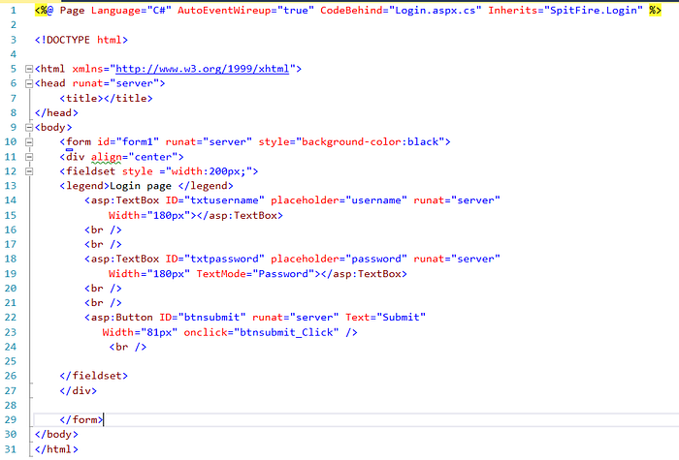

Login Screen


Error Screen

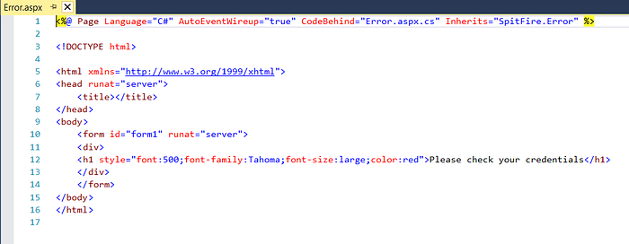

Welcome Screen

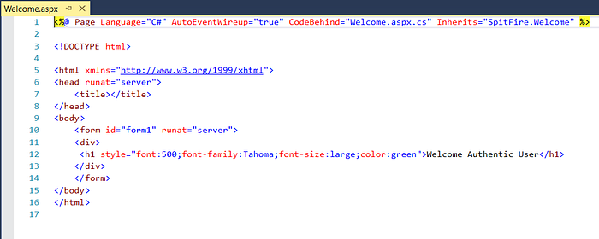

Created SQL Server Database SpitFireDB and table TblLogin using below Queries:

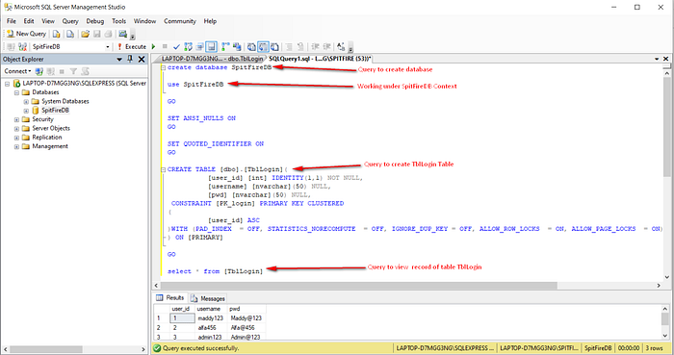

Database Queries to Create Database and Table
So far, we have created Database and Tables and Designer web pages. Now we need to write code for login page under Button_Click event so that when we click Submit button it will trigger event handler for Login Button and check user entered credentials with database and based on correct credential it will provide access to Welcome Screen or redirect user to Error Screen. I have written following code to do that,

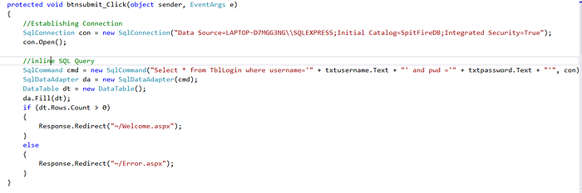

Login Screen Code on Button Click to perform credential check with database
Notice as shown above, Most of the developer write inline SQL queries directly into code to perform dynamic task. Here user supplied input for Username and Password will be captured from txtusername.Text Textbox and txtpwd.Text Textbox and appended into inline SQL queries without any validation and sanitization which will later leads to Authentication Bypass.below.

If user credentials are correct then it will redirect to Welcome Screen. I have inserted Breakpoint into code to make readers understand how correct credentials redirect user to Welcome Screen and Wrong Credentials on Error Screen.
Correct Credentials are Any of given below:
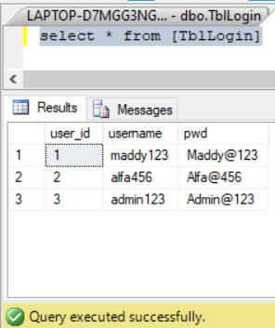

Correct Set of Credentials
When Credentials are Correct:

Debugger shows Correct credentials in CommandText Property and Redirection on Welcome.aspx Screen

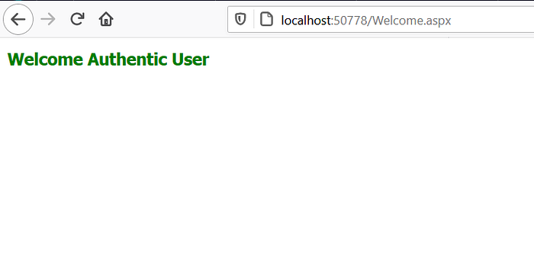

Redirection on Welcome.aspx Screen on Correct Credentials
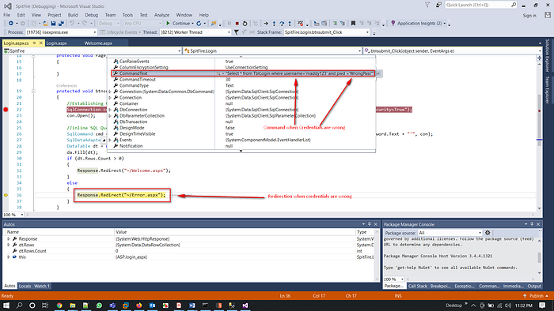
When Credentials are Wrong:

Debugger shows Wrong credentials in CommandText Property and Redirection on Error.aspx Screen
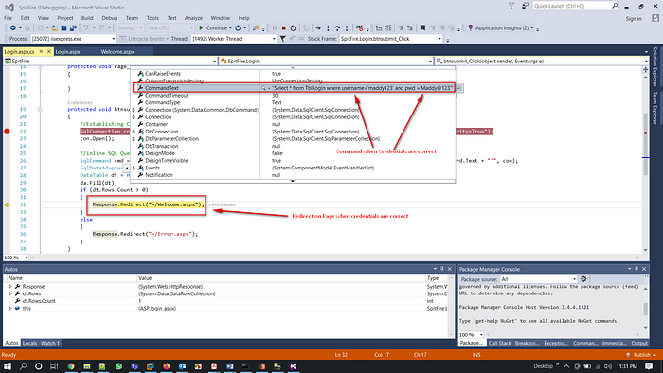

Redirection on Error.aspx Screen on Wrong Credentials
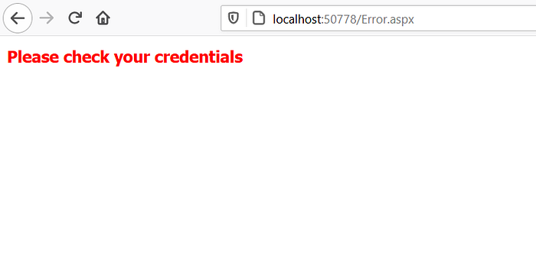

So far, I have shown normal behaviour of the web application with proof with the help of debugging that How web application send different responses and redirect on different web page based on authenticity of entered credentials. Now lets come to our pen-testing part and let’s try to bypass authentication by entering wrong credentials. Let’s call it as “Hacker’s Way of Exploitation”
Payload Used: ‘ or 1=1--
Now try to login using Hacker’s perspective let’s see whether we can login using wrong credentials. Below figure shows I have entered wrong credentials which is,
Wrong Credentials:
Username: ‘ or 1=1--
Password: foo

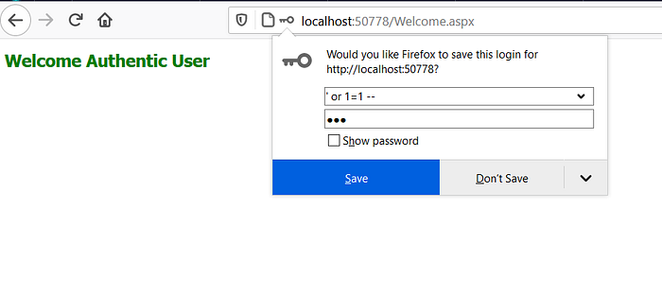

Wrong Credentials Redirects to Welcome Screen
But there are no magic at all. Let’s understand How wrong credentials allows hackers to login into application. So when we entered payload ‘ or 1=1-- on Username Textbox. Our backend dynamic query got break into Three different part as shown below:
1st Part was taken as a String: “Select * from TblLogin where username=”
2nd Part always makes Query to be return TRUE value: 1=1
3rd Part Comments REST of the Query because of:--
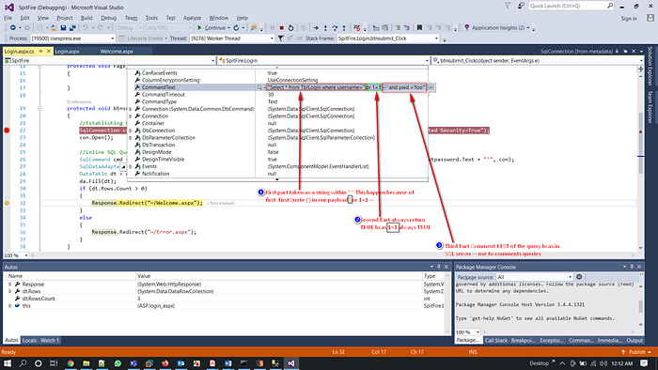

Debugging: Understanding Query Logic which incorporates our payload ‘ or 1=1-- and Bypass Authentication Mechanism

RESULT:
Thus the authentication and authorization using SQL injection executed successfully.

VIVA QUESTIONS:
- What is SQL injection?
- How does SQL injection occur?
- What are the potential consequences of SQL injection attacks?
- What are some best practices for securing database-driven applications against SQL injection attacks?
- Can you provide an example of how to defend against SQL injection using parameterized queries?

ASSIGNMENTS:

Q.No | Questions | CO Mapping | BT Level | Complexity
1 | Case Study:  Choose a real-world case study of a notable SQL injection attack. This could be a recent incident or a historical attack.  Analyze the attack scenario, including how the vulnerability was exploited and its impact on the affected organization or system. | CO1 | Create | High
2 | Prevention Techniques:  Identify and describe at least three techniques for preventing SQL injection attacks in web applications.  Provide code examples or implementation guidelines for each prevention technique.  Explain the advantages and limitations of each technique. | CO1 | Create | High

Ex.No 10 DEFEND AGAINST SQLI ATTACKS

AIM: To implement defend against SQLi attacks

PROCEDURE :
Database Connection: The script establishes a connection to the MySQL database using the mysql.connector module. This connection is essential for executing queries against the database.
conn = mysql.connector.connect(
host="localhost",
user="your_mysql_username",
password="your_mysql_password",
database="sqli_authorization_example"
)
Replace "your_mysql_username" and "your_mysql_password" with your actual MySQL username and password. This establishes a connection to the database named sqli_authorization_example running on localhost.

Prepared Statement: Instead of constructing SQL queries by concatenating strings, the script uses parameterized queries. This is crucial for defending against SQL injection attacks. Parameterized queries separate SQL code from user input, preventing malicious inputs from altering the SQL logic.
query = "SELECT * FROM users WHERE username = %s"
cursor.execute(query, (username,))
query = "SELECT * FROM users WHERE username = %s"
cursor.execute(query, (username,))
(),
The result is retrieved using cursor.fetchone which fetches the next row of the result set returned by the query. If a matching record is found in the database for the provided username, it is stored in the result variable.
Authorization Check: The script checks the role associated with the username retrieved from the database. If the role is 'admin', it indicates that the user is authorized as an admin.

The result is retrieved using cursor.fetchone(), which fetches the next row of the result set returned by the query. If a matching record is found in the database for the provided username, it is stored in the result variable.
Authorization Check: The script checks the role associated with the username retrieved from the d atabase. If the role is 'admin', it indicates that the user is authorized as an admin.

RESULT:
Thus the Program for defend against SQLi attacks program was executed successfully.

VIVA QUESTIONS:

Are there any other ways to mitigate against malicious SQL injection attempts besides using prepared statements and stored procedures?

How would you test for SQL injection vulnerabilities?

What is Union-based SQL injection? Can you describe what happens during this type of attack?

How do you know if a parameterized query has been created correctly?

Why do you think the “like” operator is so dangerous in the context of SQL injection?

ASSIGNMENTS:

Q.No | Questions | CO Mapping | BT Level | Complexity
1 | Research:  Conduct research to understand the various types of SQL injection attacks and their implications.  Explore common techniques used by attackers to exploit SQL injection vulnerabilities in web applications.  Investigate best practices and defense mechanisms for preventing SQL injection attacks. | CO1 | Create | High
2 | Case Study Analysis:  Choose a real-world case study of a SQL injection attack on a web application.  Analyze the attack scenario, including how the vulnerability was exploited, the impact on the affected system, and any mitigating factors.  Identify lessons learned and recommendations for improving the security posture of the application. | CO1 | Create | High

Ex. No: 11 ENCRYPTION AND DECRYPTION

AIM:
To write queries to insert encrypted data into the database and to retrieve the data using decryption.

PROCEDURE:
Create the Stored Procedure for Inserting Encrypted Data:
CREATE PROCEDURE InsertEncryptedData
@dataToEncrypt NVARCHAR(MAX),
@encryptionKey NVARCHAR(50)
AS
BEGIN
DECLARE @encryptedData VARBINARY(MAX);
SET @encryptedData = ENCRYPTBYKEY(KEY_GUID('SymmetricKey'), @dataToEncrypt);

INSERT INTO YourTableName (EncryptedContent)
VALUES (@encryptedData);
END;

Create the Stored Procedure for Retrieving Decrypted Data:
CREATE PROCEDURE RetrieveDecryptedData
@id INT,
@decryptionKey NVARCHAR(50)
AS
BEGIN
DECLARE @decryptedData NVARCHAR(MAX);
SELECT @decryptedData = CONVERT(NVARCHAR(MAX), DECRYPTBYKEY(EncryptedContent))
FROM YourTableName
WHERE ID = @id;

SELECT @decryptedData AS DecryptedContent;
END;

Executing the Stored Procedures:
To insert encrypted data:
EXEC InsertEncryptedData 'SensitiveData', 'EncryptionKey';
To retrieve decrypted data:
EXEC RetrieveDecryptedData @id = 1, @decryptionKey = 'DecryptionKey';
Replace 'SensitiveData' with the data you want to encrypt, 'EncryptionKey' with the encryption key, 'YourTableName' with the name of your table, 'DecryptionKey' with the decryption key, and 1 with the ID of the data you want to retrieve.

Running the Source Code:
You can execute these stored procedures using SQL Server Management Studio or any other SQL client. open a new query window, paste the code, and execute it.

RESULT:

Thus the encryption and decryption are executed successfully.

VIVA QUESTIONS

- What is encryption, and why is it important for data security?
- Explain the difference between symmetric and asymmetric encryption.
- How does encryption help protect sensitive information in a database?
- Describe the process of inserting encrypted data into a database.
- What are the potential risks associated with storing encryption keys in a database?
- How do you ensure that encryption keys are securely managed and stored?
- What SQL functions are commonly used for encryption and decryption in a database?

ASSIGNMENT

Q.No | Questions | CO Mapping | BT Level | Complexity
1 | Sensitive Information Masking:  -Create a database schema for storing sensitive information such as email addresses, phone numbers, etc.  -Implement SQL queries to mask or encrypt parts of this sensitive information to protect privacy.  -Develop SQL queries to decrypt or unmask the information for authorized users when necessary. | CO2 | Design | High
2 | Encrypted Backup:  -Design a backup system for sensitive data stored in a database.  -Use SQL queries to encrypt the backup files before storing them in a secure location.  -Implement SQL queries to decrypt the backup files when restoring data from the backup. | CO2 | Design | High

BEYOND
THE
SYLLABUS

Ex. No: 12 Optimizing Grocery Store Inventory Management

AIM : Develop and implement an efficient algorithm using SQL to optimize inventory store management for a grocery.
PROCEDURE:
Experiment Setup:
Database Creation:
CREATE TABLE products (
product_id INT PRIMARY KEY,
product_name VARCHAR(255),
supplier_id INT,
unit_price DECIMAL(10, 2)
);

CREATE TABLE suppliers (
supplier_id INT PRIMARY KEY,
supplier_name VARCHAR(255),
delivery_time INT,
quality_rating DECIMAL(5, 2),
price_rating DECIMAL(5, 2)
);

CREATE TABLE inventory (
product_id INT,
quantity INT,
FOREIGN KEY (product_id) REFERENCES products(product_id)
);

Data Population: Populate the tables with sample data.
Algorithm Design and SQL Implementation:
Predicting Future Demand: Use historical sales data to predict future demand for each product

-- Example query to calculate average daily sales for each product
SELECT product_id, AVG(sales_quantity) AS avg_daily_sales
FROM sales
GROUP BY product_id;
Reorder Recommendation: Determine reorder quantities based on predicted demand and current inventory levels.
-- Example query to calculate reorder quantity
SELECT product_id,
CASE
WHEN (current_inventory + reorder_lead_time * avg_daily_sales) < safety_stock THEN safety_stock - current_inventory
ELSE 0
END AS reorder_quantity
FROM (
p.product_id,
i.quantity AS current_inventory,
s.delivery_time AS reorder_lead_time,
(SELECT AVG(sales_quantity) FROM sales WHERE product_id = p.product_id) AS avg_daily_sales,
-- Example safety stock calculation (can be adjusted based on business requirements)
ROUND(1.5 * (SELECT AVG(sales_quantity) FROM sales WHERE product_id = p.product_id), 0) AS safety_stock
FROM products p
JOIN inventory i ON p.product_id = i.product_id
JOIN suppliers s ON p.supplier_id = s.supplier_id
) AS reorder_info;
Program output:
Inventory Reports: Use SQL queries to generate reports showing current inventory levels, predicted demand, and recommended reorder quantities.
Supplier Performance Analysis: Analyze supplier performance using SQL queries based on delivery times, quality ratings, and price ratings.

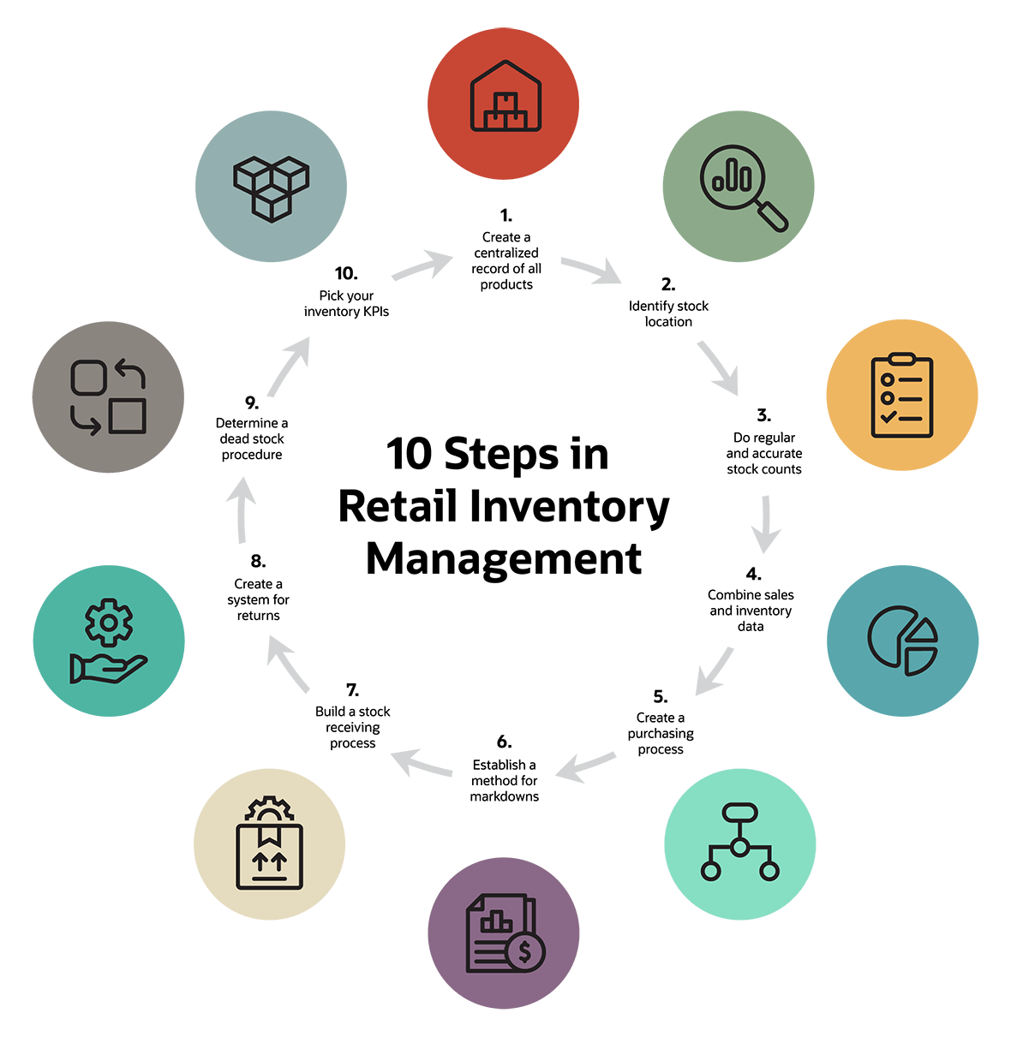

Metrics: Calculate metrics such as inventory turnover rate, carrying costs, and stockout costs using SQL queries.
Graphical Visualization: Visualize the data using charts or graphs using SQL or a programming language like Python with libraries like matplotlib or seaborn.
Expected Results:
inventory management leading to reduced stockouts and overstock.
Enhanced supplier relationships through better performance analysis.
Cost savings from optimized inventory levels and reduced carrying costs.

RESULT:
Thus the optimization of inventory store management for a grocery was executed successfully.

VIVA QUESTIONS
- What is an inventory management system, and why is it important for businesses?
- What are the main challenges faced in inventory management for a grocery store?
- How does optimizing inventory management benefit a grocery store?
- Explain the importance of accurate demand forecasting in grocery store inventory management.
- How can data analytics and algorithms be leveraged to optimize inventory management in a grocery store?

ASSIGNMENTS:
Q.No | Questions | CO Mapping | BT Level | Complexity
1 | Inventory Management:  Develop a system for inventory tracking and management.  Establish relationships with suppliers or wholesalers.  Determine storage and fulfillment logistics. | CO1 | Create | High
2 | Website Development:  Design an intuitive and user-friendly website.  Implement secure payment gateways for transactions.  Ensure mobile responsiveness for easy access on smartphones and tablets.  Include features like search filters, shopping carts, and account management. | CO2 | Design | Moderate

EX.NO 13 BLOCKCHAIN CONCEPT USING SQL

AIM: To implement the structure of block chain using SQL table.

PROCEDURE:
1. Table Structure:
First, we define the structure of our blockchain using a SQL table. This table will store information about each block in the blockchain.
CREATE TABLE blocks (
id INTEGER PRIMARY KEY,
timestamp TEXT,
data TEXT,
previous_hash TEXT,
hash TEXT
);
id: This is an auto-incrementing integer and serves as a unique identifier for each block.
timestamp: Represents the time when the block was created.
data: Contains the actual data or transactions stored in the block.
previous_hash: Stores the hash value of the previous block in the chain.
hash: Represents the hash value of the current block, calculated based on the block's data and previous hash.
2. Creating the Genesis Block:
The genesis block is the first block in the blockchain, and it doesn't have a previous block. We insert it manually into the database.
INSERT INTO blocks (timestamp, data, previous_hash, hash)
VALUES ('2022-03-07 00:00:00', 'Genesis Block', '0', 'f5d9c6c1c586b5d9f4d6b362cff89b47d4c6b77a1b6f2e4a6052b145216aa602');
Here, we provide the timestamp, data (in this case, just a string "Genesis Block"), previous hash (which is set to '0' indicating no previous block), and the hash value of the block (calculated based on its attributes).
3. Adding Subsequent Blocks:
After the genesis block, we can add new blocks to the blockchain. Each new block's previous hash will be the hash of the previous block, ensuring the integrity of the blockchain.
INSERT INTO blocks (timestamp, data, previous_hash, hash)
VALUES ('2022-03-07 00:01:00', 'Some data for block 1', 'f5d9c6c1c586b5d9f4d6b362cff89b47d4c6b77a1b6f2e4a6052b145216aa602', '44b911be57640fe95a088d4c3b9ad84ab9a2f22ec832e8fffb0f5b5e168ed975');
INSERT INTO blocks (timestamp, data, previous_hash, hash)
VALUES ('2022-03-07 00:02:00', 'Some data for block 2', '44b911be57640fe95a088d4c3b9ad84ab9a2f22ec832e8fffb0f5b5e168ed975', '1b2a5b8f1221d591e78732eb2b030fdb7e4f38363018f3b7b6b11e4bf08b5291');

Each subsequent block contains a timestamp, some data, and the hash of the previous block.
The hash value of the new block is calculated based on its attributes (timestamp, data, and previous hash).

Checking Blockchain Integrity:
We can perform checks to ensure that the blockchain remains intact and has not been tampered with. This involves verifying that the hash of each block matches the value stored in the hash column and that the previous_hash value of each block matches the hash of the previous block.
-- Check if hashes match
SELECT *
FROM blocks
WHERE hash != SHA256(CONCAT(timestamp, data, previous_hash));
-- Check if previous_hash values are correct
SELECT b1.id, b1.previous_hash, b2.hash AS previous_block_hash
FROM blocks b1
JOIN blocks b2 ON b1.previous_hash = b2.hash
WHERE b1.previous_hash != '0';
The first query checks if the hash values stored in the hash column match the calculated hash of each block.
The second query checks if the previous_hash values stored in each block match the hash of the previous block.
These SQL queries provide a simplified representation of how blockchain concepts such as block creation, chaining, and integrity checking can be implemented using SQL database operations. In a real-world scenario, additional considerations such as indexing, optimization, and security measures would need to be taken into account.
RESULT:
Thus the structure of block chain using SQL was implemented successfully.

VIVA QUESTIONS:
- What is a blockchain?
- How does blockchain ensure immutability and security of data?
- How does a blockchain achieve decentralization?
- What are the benefits and challenges of blockchain technology?
- What are the different types of consensus mechanisms used in blockchain?
- What are some real-world applications of blockchain technology

ASSIGNMENTS
Q.No | Questions | CO Mapping | BT Level | Complexity
1 | Blockchain Data Model Design:  Task: Design a SQL database schema to store blockchain data. Define tables for blocks, transactions, and addresses, along with appropriate relationships and constraints.  Requirements: Create tables with columns for block height, timestamp, transaction ID, sender address, recipient address, amount, and other relevant fields. Implement primary keys, foreign keys, and indexes for efficient data retrieval.  . | CO5 | Create | Moderate
2 | Blockchain Integrity Verification:  Task: Develop SQL queries to verify the integrity of the blockchain by comparing block hashes and previous hashes.  Requirements: Write SQL queries to check if the hash of each block matches the calculated hash based on Its data and previous hash. Validate that the previous hash of each block matches the hash of the previous block in the chain. | CO5 | Create | High

INNOVATIVE PROJECT

Intelligent DB: Next-Generation Database Management System

Overview:
IntelligentDB is a cutting-edge database management system designed to meet the demands of modern data-driven applications. It leverages advanced technologies such as machine learning, blockchain, and real-time processing to provide unparalleled performance, security, and scalability. IntelligentDB empowers businesses and organizations to manage their data efficiently, extract actionable insights, and drive innovation.
Key Features:
Machine Learning-Driven Query Optimization:
IntelligentDB employs machine learning algorithms to analyze query patterns and optimize query execution plans in real-time.
By continuously learning from past performance and user behavior, IntelligentDB ensures optimal resource utilization and response times.
Blockchain Integration for Data Security:
Built-in blockchain integration ensures data immutability, transparency, and tamper-proof audit trails.
Smart contracts govern access control policies, providing granular permissions and ensuring data integrity.

Real-time Data Streaming and Processing:
Support real-time data ingestion from various sources such as IoT devices, sensors, and social media feeds.
Enable real-time analytics and decision-making through continuous data processing capabilities.
Graph Database Capabilities:
Incorporate graph database functionality for handling complex relationships and network structures.
Enable advanced graph querying and analytics for applications such as social networks, recommendation systems, and fraud detection.
Natural Language Processing (NLP) for Querying:
Implement NLP techniques to allow users to query the database using natural language commands.
Utilize NLP

